### **📊 Executive Summary: Social Media Addiction Analysis Among Students**

This data analysis project explores the impact and patterns of social media addiction among students using a dataset of **705 students** across various academic levels. The insights were drawn using Excel dashboards, charts, and interactive slicers for filtering by **Academic Level** (Graduate, Undergraduate, High School) and **Most Used Platforms** (e.g., Instagram, Facebook).

### **✅ Key Findings**

1. **📱Average Daily Social Media Usage**
   * The average student spends approximately **5 hours daily** on social media, indicating a high level of engagement or dependence.

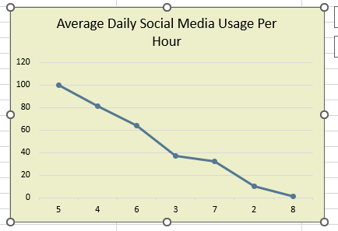

1. **🌍 Country-wise Student Distribution (Top 10 Countries)**
   * **India** leads in student count, reflecting either higher survey participation or more prominent social media usage among Indian students.

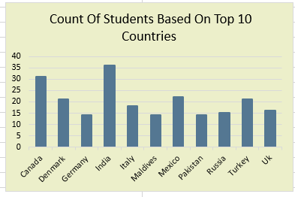

1. **🧠 Mental Health Score by Gender**
   * **Male students** reported a combined mental health score of **1753**, whereas **female students** reported **318**.  
      *(Note: This indicates either a difference in response rate or variation in mental health impact that may need further investigation.)*

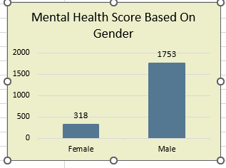

1. **📷 Most Used Platforms**
   * The most popular platforms among students are **Facebook** and **Instagram**, highlighting their dominant role in shaping student behavior and possibly addiction patterns.

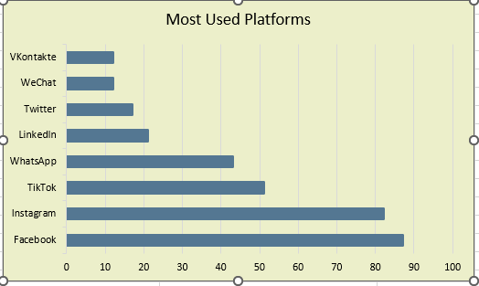

1. **❤️ Relationship Status Distribution**
   * **Single:** 48%
   * **In a Relationship:** 50%
   * **It’s Complicated:** 2%  
      This shows an almost even split, with social media possibly influencing relationship dynamics or vice versa.

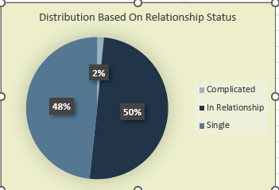

1. **🎓 Impact of Social Media on Academic Performance**
   * **61%** of students acknowledged that social media affects their academics, while **39%** believed it doesn’t.  
      This indicates a majority are aware of potential academic distractions caused by social media.

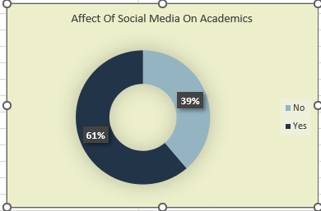

1. **👶 Age Distribution of Students**
   * Students aged **21 and 22** constitute the largest portion of the dataset, representing the typical undergraduate age group.

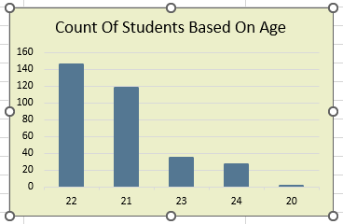

1. **😴 Age-wise Comparison: Sleep Hours vs Social Media Usage**
   * An age-wise comparison chart reveals patterns where **higher social media usage often correlates with reduced sleep**, especially in early 20s age brackets.  
      This supports concerns about social media's impact on student sleep hygiene.

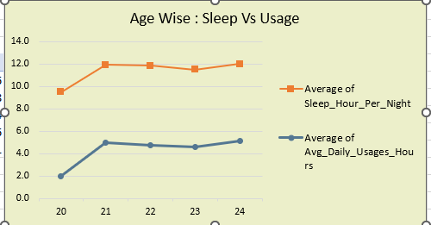

### **🔎 Interactive Features**

* **Academic Level Slicer:** Enables filtering to view trends across high school, undergraduate, and graduate students.
* **Most Used Platform Slicer:** Allows platform-specific behavior analysis to assess whether certain apps influence mental health, sleep, or academics more significantly.

### **📌 Conclusion**

The analysis reveals **critical behavioral patterns** associated with social media use among students, emphasizing the need for **awareness and digital well-being programs**. Given the evident impacts on mental health, sleep, and academic performance, this data-driven insight can be useful for educators, counselors, and policymakers.